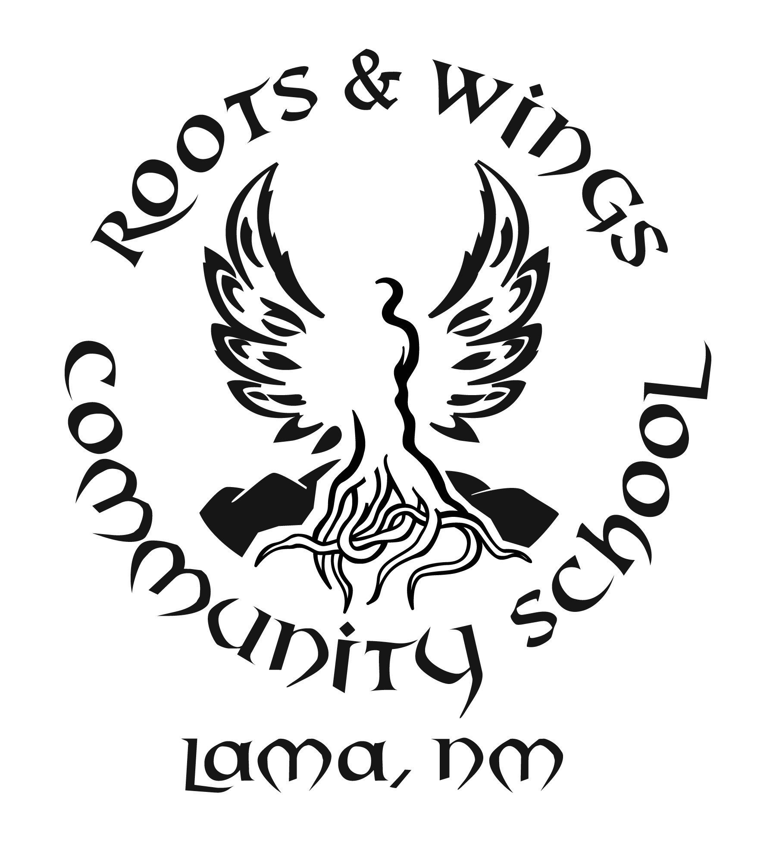

Governing Council Meeting Schedule
School Year 2020-2021

Meetings shall be held at 5pm every third Tuesday of the month
either on campus or virtually due to the COVID-19 pandemic. Changes in meeting dates, special meetings and emergency meetings shall be posted on the RWCS website no later than 72 hours prior to the meeting.

July 21st, 2020
August 18th, 2020
September 15th, 2020
October 20th, 2020
November 17th, 2020
December 15th, 2020
January 19th, 2021
February 16th, 2021
*March 16th, 2021*
April 20th, 2021
May 18th, 2021
June 15th, 2021

