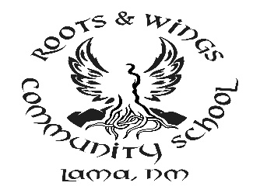
Roots & Wings Community School
NOTICE OF 2019-20 OPERATING BUDGET APPROVAL

Notice is hereby given pursuant to 22-8-10 NMSA 1978 that the Governing Council of Roots & Wings Community School, County of Taos, State of New Mexico will on Monday, April 22, 2019, 5:00 p.m., at a Regular Board meeting at Roots & Wings Community School, 35 La Lama Road, Lama, NM, present and publicly review the Operating Budget for the 2019-20 fiscal year. This is a public hearing and school patrons and the general public are invited to attend.

