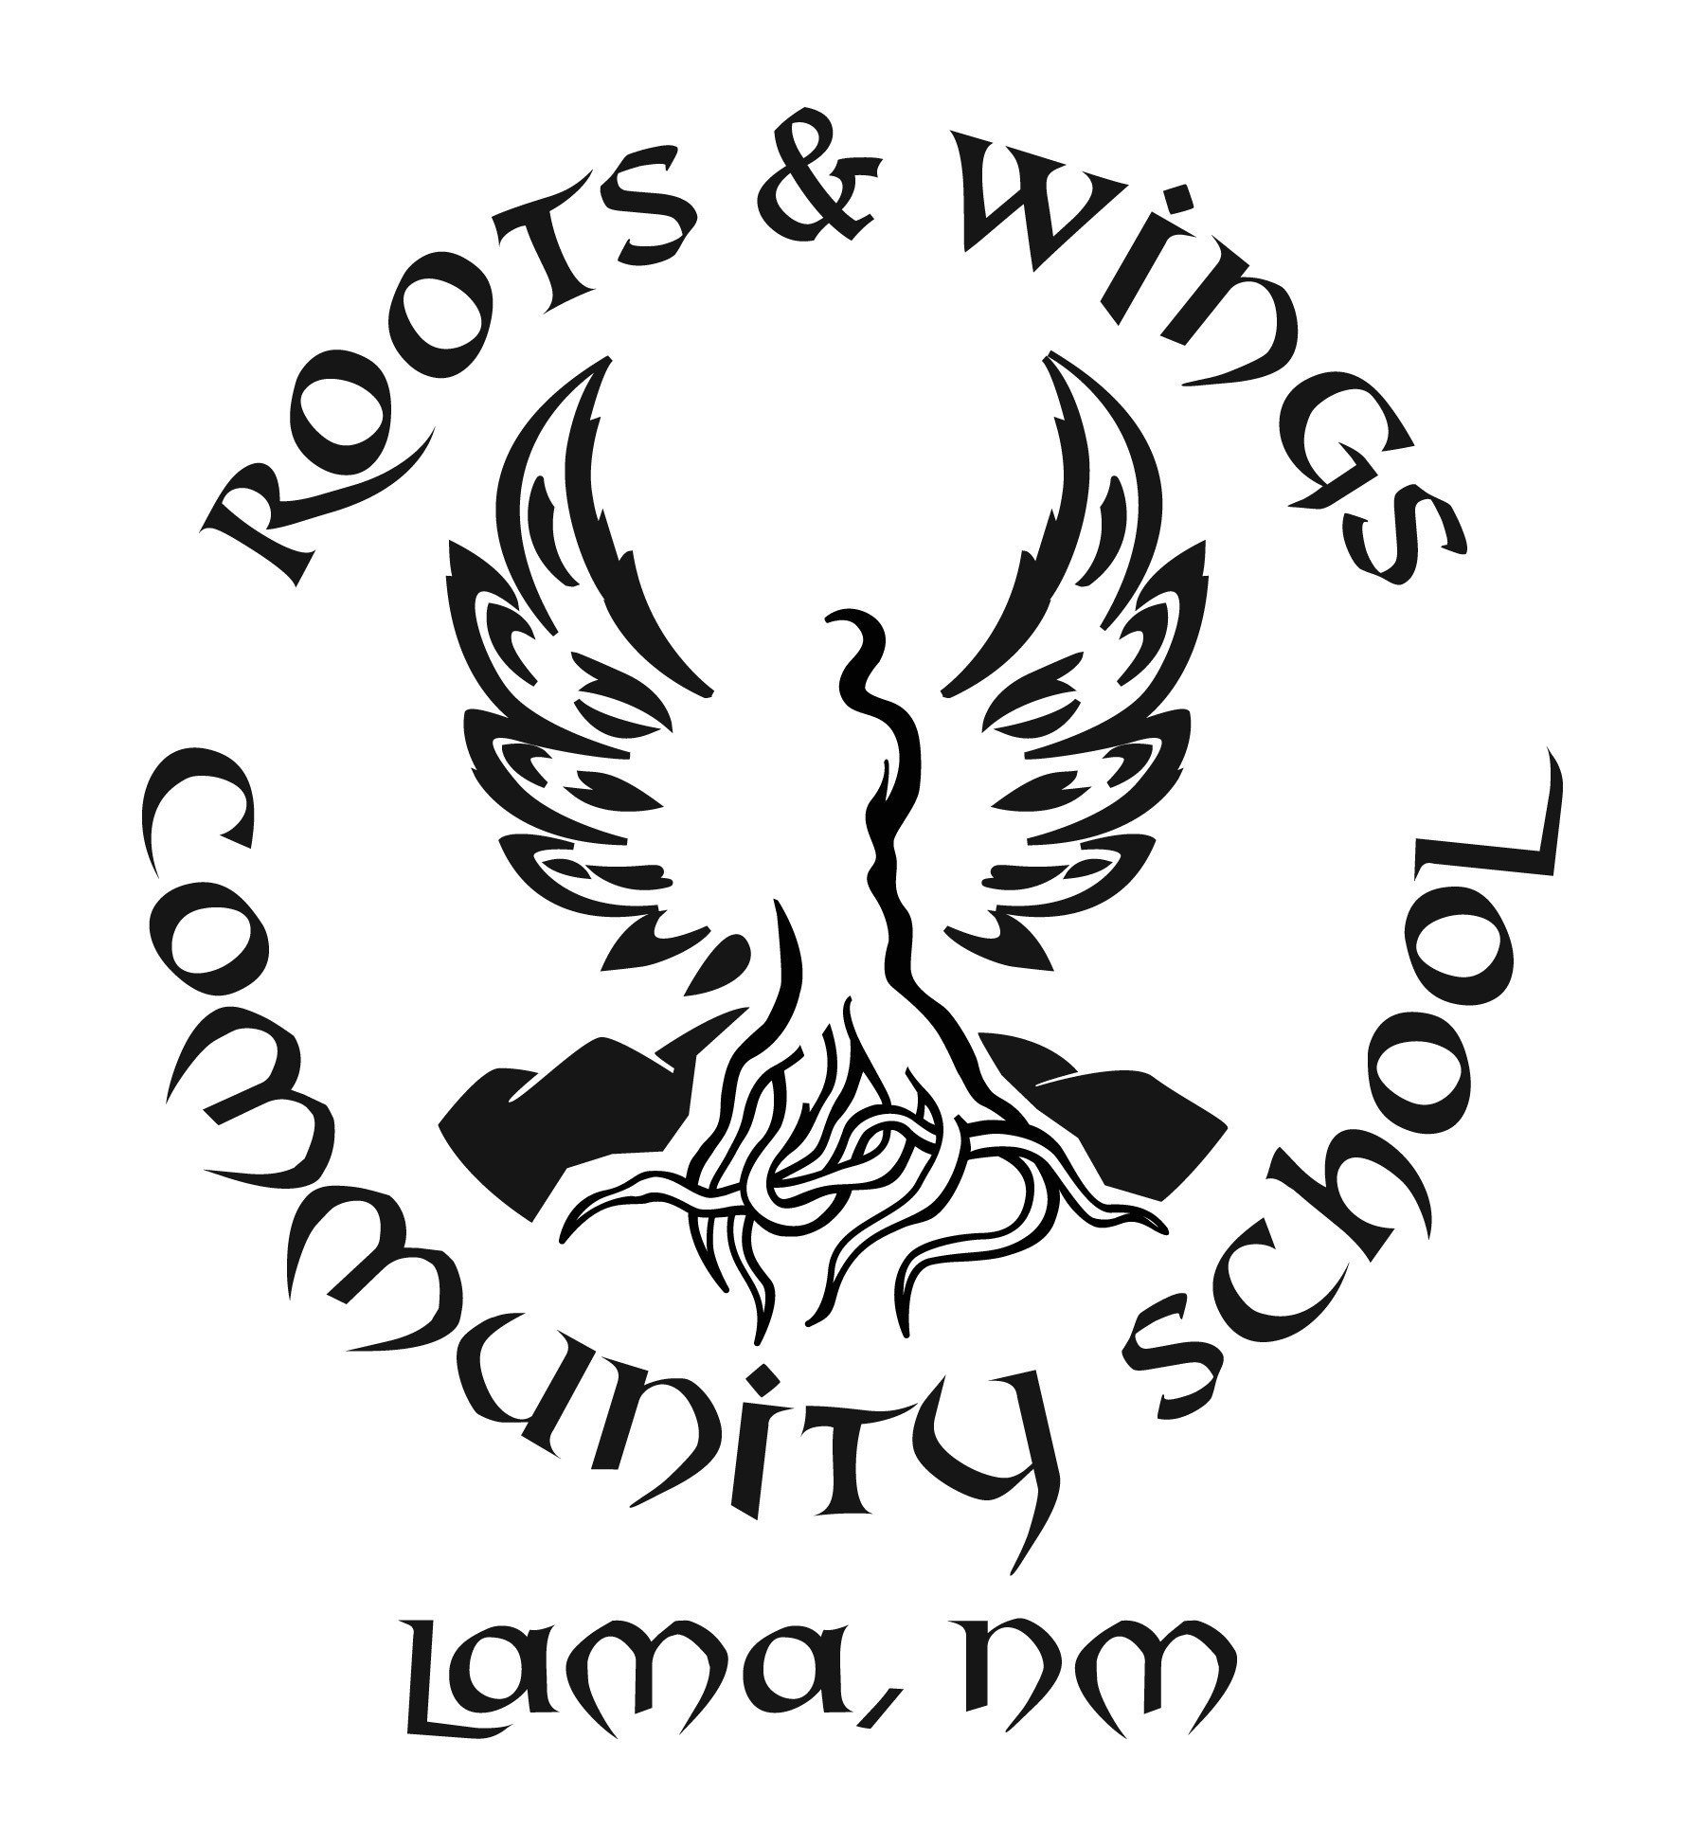

Governing Council Meeting Schedule
School year 2018-2019

Meetings shall be held on campus at 5pm every third Tuesday of the month, unless marked with *.
September 18th, 2018
October 16th, 2018
*November 13th, 2018 (second Tuesday due to Thanksgiving)
*December 13th, 2018 (Thursday due to school program conflict)
January 15th, 2019
February 19th, 2019
March 19th, 2019
April 22nd , 2019
May 21st, 2019
June 18th, 2019

